Assignmet – 9

Q1. Write a JAVA program to read a string from the key board and print its reverse. Also check whether the string is palindrome or not.
Code:
import java.util.Scanner;
class Q1{
public static void main(String[] args) {
Scanner sc = new Scanner(System.in);
System.out.print("Enter a String: ");
String string = sc.next();
StringBuilder reversed = new StringBuilder(string).reverse();
System.out.println("Reversed String is: " + reversed);
if (string.contentEquals(reversed)) {
System.out.println(string + " is a palindrome");
} else {
System.out.println(string + " is not a palindrome");
}
sc.close();
}
}
Output:
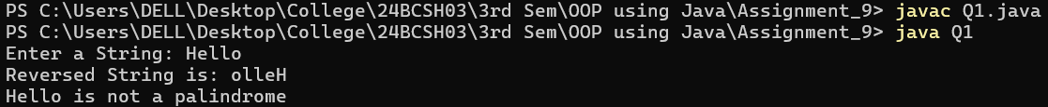
Q2. Write a JAVA program to capitalize first letter of each word in an inputted sentence from keyboard.
Sample Output:
Enter a sentence: india is great
India Is Great
Code:
import java.util.Scanner;
class Q2 {
public static void main(String[] args) {
Scanner sc = new Scanner(System.in);
System.out.print("Enter a sentence: ");
String s = sc.nextLine();
StringBuilder sb = new StringBuilder(s.length() + 1);
for (String word : s.split(" ")) {
sb.append(Character.toUpperCase(word.charAt(0))).append(word.substring(1)).append(' ');
}
System.out.println("Transformed String is: " + sb);
sc.close();
}
}
Output:
Q3. Write a JAVA program to convert a string into uppercase.
Code:
import java.util.Scanner;
class Q3 {
public static void main(String[] args) {
Scanner sc = new Scanner(System.in);
System.out.print("Enter a String: ");
String s = sc.nextLine();
System.out.println("The UpperCased String is: " + s.toUpperCase());
sc.close();
}
}
Output:
Q4. Write a Java program to input a string and print the total number of characters present in the string.
Code:
import java.util.Scanner;
class Q4 {
public static void main(String[] args) {
Scanner sc = new Scanner(System.in);
System.out.print("Enter a String: ");
String s = sc.nextLine();
System.out.println("The Total number of Characters present in " + "'" + s + "'"+ " are : " + s.length());
sc.close();
}
}
Output:
Q5. Write a java program to replace a substring with another string.
Code:
import java.util.Scanner;
class Q5 {
public static void main(String[] args) {
Scanner sc = new Scanner(System.in);
System.out.print("Enter a String: ");
String S = sc.nextLine();
System.out.print("Enter the Sub-String to be Replaced: ");
String s = sc.nextLine();
System.out.print("Enter the String to replace with: ");
String R = sc.nextLine();
System.out.println("The Original String is : " + S);
System.out.println("String After Replacement: " + S.replace(s, R));
sc.close();
}
}
Output:
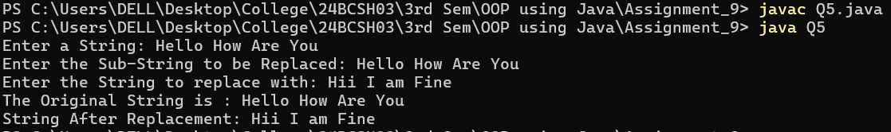
Q6. Write a program that computes your initials from your full name and displays them.
Code:
import java.util.Scanner;
class Q6 {
public static void main(String[] args) {
Scanner sc = new Scanner(System.in);
System.out.print("Enter your full name: ");
String name = sc.nextLine();
String[] words = name.split(" ");
StringBuilder sb = new StringBuilder(words.length);
for (String word : words) {
sb.append(Character.toUpperCase(word.charAt(0)));
}
System.out.println("Your Initials String is: " + sb);
sc.close();
}
}
Output:
Q7. Write a program that receives two strings and check whether they are equal or not.
Code:
import java.util.Scanner;
class Q7 {
public static void main(String[] args) {
Scanner sc = new Scanner(System.in);
System.out.print("Enter First String: ");
String s1 = sc.next();
System.out.print("Enter Second String: ");
String s2 = sc.next();
if (s1.equals(s2)) {
System.out.println(s1 + " and " + s2 + " are Equal.");
} else {
System.out.println(s1 + " and " + s2 + " are Not Equal.");
}
sc.close();
}
}
Output:
